The Trust’s core aim is to ensure that we enhance the life chances of all the young people within the Trust to enable them to fulfil their potential and achieve the best possible outcomes. This is at the heart of everything we do.

Zenith MINDS is a MAT wide provision to enhance the life chances of all young people within the academy trust, making sure the approach to support is child-centred and ensures; at all times, the wishes, needs and best interest of the child are paramount.

In September 2018 a Zenith member of staff was appointed as Director of Student welfare with a focus on improving opportunities for student support. The Zenith MINDS project started in December 2018 with a vision of accessible support that is bespoke to the needs of individual students. The provision will be implemented for start of autumn term and it will enable young people to fulfil their potential and achieve the best possible outcomes.

We work with our growing family of local primary, secondary and teaching schools to have a provision that puts the needs of students at the centre, whilst working collaboratively with other MATs and organisations to make this vision a reality.

We aim to have a provision that enables access to:

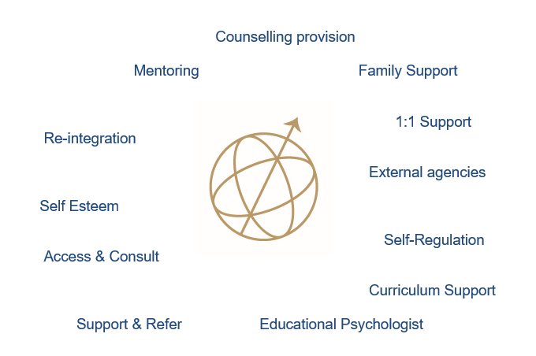

We endeavour:
- Provide a service that puts the needs of the students at the centre
- Provide a bespoke support package to meet the needs of the student
- To access services that bridge the gap between school provision and regional provision
- Provide support for safeguarding, mental health and well-being concerns
- Provide professional advice and consultation on student cases
- Provide guidance and support for staff
- Provide a centre that is a positive, calm and supportive environment where students can be mentally healthy and safe

The service will have access to:
- Provision manager who will coordinate referrals in and out of the provision, assessing the needs and appropriate next steps for each individual student accessing the provision
- Student welfare officer who will focus specifically on the individualised support needs of the student ensuring they achieve their potential and best possible outcomes
- Family support worker who will work with hard to reach/ vulnerable families, bridging the gap between student and family as well as family and school
- Counselling provision
- Educational psychologist consultation and assessments
- Staff supervision and support

Job Description
Job Title: Zenith Minds Support Assistant
Grade: Band 2 - Mid
Reports to: Zenith Minds Provision Manager and Director of Student Welfare
Liaison with: Director of Student Welfare, Zenith Minds Provision Manager, Pastoral teams, SEN, Students/Parents and Teaching Staff in each MAT school.
Job Purpose:
- To enhance the life chances of all young people within the academy trust, making sure the approach to support is child-centred and ensures; at all times, the wishes, needs and best interest of the child are paramount.
- Provide social, emotional and educational welfare support to students ensuring a holistic approach for the most vulnerable students across the MAT.
- Responsible for all aspects of student welfare, ensuring effective support for well-being and safety.
- Adapt and offer support as required to ensure that all elements of student welfare are addressed and maintained.

Specific Duties:
- Have close working relationships with DSL, Pastoral teams (including attendance and behaviour) and SEN to ensure students are referred, monitored and re-integrated effectively.
- Provide social, emotional and educational welfare support to students ensuring a holistic approach to ensure their needs are met.
- Responsible for all aspects of student welfare, ensuring effective support for well-being and safety, planning appropriate interventions to support and meet the needs of each student referred.
- Work with the Zenith Minds Manager to ensure a clear focus on student academic progress and success. Equipping students with the behaviours and attitudes to ensure they are successful.
- Understand the range of barriers that impact student progress and support with appropriate intervention to remove the educational barriers to learning and progress.
- Offer in-provision support for all elements of learning. Assist with the development and implementation of action plans or learning plans.
- Understand specific learning needs and styles and provide differentiated support to learners individually and within a group.
- Implement planned learning activities/teaching programmes as agreed with the teacher, adjusting activities according to learners’ responses as appropriate.
- To attend to learners’ personal needs including help with social, welfare, care and health matters, including all aspects of personal care, mobility etc.
- Liaise with staff and other relevant professionals and provide information about learners as appropriate.
- Maintaining excellent records of all support, action and outcomes.
- Develop bespoke and individual plans of support to meet student needs. Including building positive relationships with families.
Requirements:
- Mental Health Specialist and experience of working in this field
- Experience of working with and supporting young people
- Experience in responding to MH needs of young people
- Experience in working with external agencies and making appropriate referrals
- Understanding and experience of special education needs (desirable)
- Counselling qualifications, skills, experience (desirable)
- Training and understanding of safeguarding (desirable)

