St Benedict’s Catholic College

DYSLEXIA SPECIALIST TEACHING ASSISTANT

Application Pack

Message from the Principal

St Benedict’s Catholic College is a highly respected and oversubscribed Roman Catholic 11-16 college serving Christian families throughout north-east Essex, we strive to promote the values of our Christian faith throughout our daily life.

Our 2018 Ofsted inspection found that we continue to be a good school, that pupils behaved well and like coming to school. Student attainment at GCSE in the core subjects of English and mathematics, and in science and humanities subjects, is well above average. St Benedict’s is a great place to be and I’m delighted that you are interested in applying to be part of our team.

As our mission statement says, we are proud to be an inclusive community where spiritual, emotional and academic growth are nurtured. We believe in putting learning first.

Our facilities are excellent and we have a rich variety of extra-curricular opportunities that underpin our academic success. The college is set in pleasant, spacious grounds which include hard play areas, playing fields and tennis courts. We have a well-equipped sports hall and fitness suite. Our chapel is used regularly by students and staff for worship, prayer and quiet reflection.

St Benedict’s students develop into happy confident and self-aware young adults. There are many opportunities for them to thrive and shine, through high quality teaching and numerous clubs and activities.

We are looking for a Dyslexia Specialist Teaching Assistant

The successful candidate will be:
- committed to providing the very best learning opportunities for their students
- able to challenge all students to make exceptional progress
- a strong team player who forms excellent relationships with staff, parents and students
- willing to support the strong Catholic ethos of our college

We can offer you:
- a warm and welcoming college with excellent links to parish communities
- enthusiastic and well-behaved students who are eager to learn
- supportive, hardworking staff, governors and parents
- opportunities to further your professional development

If you would like any further information, or would like to arrange an informal visit, please contact Mrs Lyndsey Humble on 01206 549222.

The post is required 1st January 2020 and the closing date for applications is 18th November 2019 at 12.00 midday. Interviews w/c 25th November 2019.

Please apply by completing an application form which can be obtained from the College website www.stbenedicts.essex.sch.uk/vacancies or by emailing a.jones@stbenedicts.essex.sch.uk. Details about how we will use the personal data you provide as part of the recruitment process can be found in our privacy notice on our website - www.stbenedicts.essex.sch.uk/welcome/privacy-notice/

The governing body is committed to safeguarding and promoting the welfare of all young people and expects all staff to share that commitment. The successful applicant will be required to complete an enhanced DBS check.

We look forward to hearing from you
Yours sincerely

Jo Santinelli
Principal

Flavour of the local area
The College is situated a short walk from Colchester Town Centre, Britain’s oldest recorded town.

Colchester is a thriving, modern town with great visitor attractions, including the family favourites Colchester Zoo and Colchester Castle, as well as fantastic places to eat, drink and shop

There is a growing arts scene in the town, with two highly acclaimed local theatres and the renowned Firstsite and Minories Galleries hosting significant art exhibitions and installations.

The town also benefits from a wide range of excellent schools and colleges as well as being the home of Essex University’s main campus.
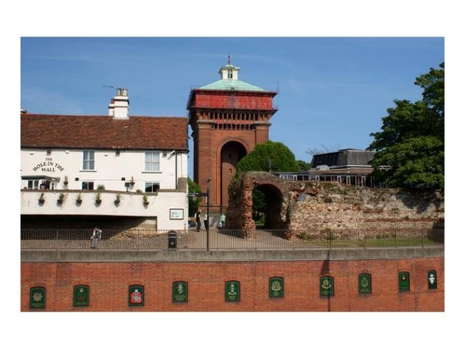
Colchester also benefits from superb transport links, including excellent road links, direct rail lines going into London (which is less than an hour away), and easy access to London Stansted and London Southend Airports which fly to a growing number of destinations throughout Europe.

DYSLEXIA SPECIALIST TEACHING ASSISTANT – Job Description
Job Description

St Benedict’s Catholic College is an inclusive college with Christ at the Centre. We nurture spiritual, emotional and academic growth. We develop our gifts and talents through prayer, work and respect

Grade Band 4 (mid)

Job Purpose To work in partnership with the SEND department to support learning in line with the national curriculum, codes of practice and the colleges policies and procedures. To provide 1-1 and small group teaching of literacy to pupils with Dyslexia.

Reports to Assistant SENCO

Job role
- To support the Catholic ethos of the College
- Provides particular and skilled support to students with Dyslexia and dyslexic tendencies
- Works with individuals or small groups of students under the direction of the SENDCo
- Understands specific learning needs and styles and provide differentiated support to students individually and within a group
- Implements planned learning activities/teaching programmes as agreed with the SENDCo, adjusting activities according to students responses as appropriate
- Establishes positive relationships with students supported
- Provides feedback to students in relation to attainment and progress
- Promotes the inclusion and acceptance of children with special needs within the classroom ensuring access to lessons and their content through appropriate clarification, explanation and resources
- Promotes positive student behaviour in line with school policies and help keep students on task
- Participates in planning and evaluation of learning activities with the SENDCo, writing reports and records as required
- Understands and apply school policies in relation to health, safety and welfare
- Complete Level 4 Dyslexia Action Certificate in Supporting Literacy in Learners within a year, with mentoring and support and take responsibility for own development
- Respects confidentiality at all times
- Deals effectively with any immediate problems or emergencies according to the school's policies and procedures.
- To report back, as appropriate, using the school's agreed referral procedures on the behaviour of pupils during the session, and any issues arising.
- To comply with individual responsibilities, in accordance with the role, for health & safety in the workplace
- Ensure that all duties and services provided are in accordance with the College’s Equal Opportunities Policy
- The Governing Body is committed to safeguarding and promoting the welfare of children and young people and expects all staff and volunteers to share in this commitment

The duties above are neither exclusive nor exhaustive and the post holder may be required by the Principal to carry out additional duties within the context of the job, skills and grade

Person specification

 | Essential | Desirable
Qualifications and experience
Grade C or above pass in English and English GCSE (or equivalent)
2 A levels at grade C or above (or equivalent)
Experience of working with students with dyslexia
Personal Qualities
Good organisational skills
Good communication skills
Good listening skills
Stamina, energy, resilience and sense of humour
Calm and patient
Team player
Flexible
Skills and abilities
Ability to plan, do and review literacy interventions
Ability to self-motivate and work under own initiative
Ability to communicate information clearly and sensitively with students and adults
Ability to observe and monitor progress and maintain records
Good understanding of the way in which children develop in relation to the role
Understand the importance of physical and emotional wellbeing
Ability to support student who maybe unwell
Ability to follow written and oral instructions and to carry out instructions.
Ability to motivate/encourage/empower students and adults.
Good understanding of the learning experience provided by the College
Establish effective relationships with those working in and with the College
Empathetic, assertive and a good role model
Able to work effectively in teams as member or leader
Understand and comply with procedures and legislation relating to confidentiality
Able to ensure that tight, strict deadlines are met
Demonstrate a commitment to equality
Understanding of Health & Safety
Understand and comply with Safeguarding and Child Protection procedures
Demonstrate a clear commitment to develop and learn in the role
Able to effectively evaluate own performance

St Benedict’s Catholic College
Norman Way
Colchester
Essex
CO3 3US
www.stbenedicts.essex.sch.uk

