February 2020
Dear Applicant
Thank you for taking an interest in a post at The Thomas Lord Audley School.
The Thomas Lord Audley School is a high performing, over-subscribed 11-16 comprehensive school, situated to the south of Colchester. It serves a wide and diverse catchment area, including Old Heath, Monkwick, Shrub End, the villages to the south of Colchester and the community of Mersea Island. Over the last four years, students have achieved a good standard of GCSE results in a wide range of subjects including English and Maths
The Thomas Lord Audley School is a community in which every student matters. We have high expectations of all students with respect to behaviour, attendance and punctuality and have developed a curriculum, which enables our students to develop as young people as well as achieve good exam results. We have a highly committed and well-qualified staff who encourage students to give their best in all aspects of school life.
As Headteacher, I very much value the commitment and determination of all our staff in ensuring that the students access a high quality education. In general, I am value driven and not inclined to game the system, off roll or focus exclusively on the quick fix. Our SLT is mature and well rounded and we have excellent relationships with colleagues. We are a happy school and have a relatively low staff turnover because staff in general feel well supported both personally and professionally. As a school, we take a considered approach to school improvement and performance management. We believe in building on our strengths and developing a few key aspects of our provision in depth and over time in order to have a sustained positive impact on students and to enable staff to experience professional satisfaction.
The school achieved a ‘Good’ in its Ofsted inspection in April 2016 and subsequently was designated the Most Improved Secondary School in Essex. In 2018 I was awarded Headteacher of the Year in a Secondary School at the Essex teacher Awards; I accepted this award on behalf of my team because we all work together to benefit all our students. We had an Ofsted Section 8 Inspection in early February and are currently awaiting the report. This will be published on the school website.
The Thomas Lord Audley School is pleased to be a member of the Sigma Trust and we fully subscribe to the Trust’s Mission, Vision and Values. We have positive relationships with our partner schools and fully engage in a wide range of activities. A number of colleagues are involved in leading aspects of Trust development at a senior level and other colleagues are participating in middle and senior leadership courses. I am keen to enable members of staff to develop their professional expertise and career.

We would very much welcome an application from you and think that if you came to work here you would have a positive experience.
Yours sincerely

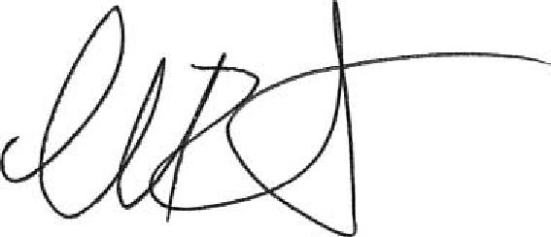

Helena Boast
Headteacher

