St Benedict’s Catholic College

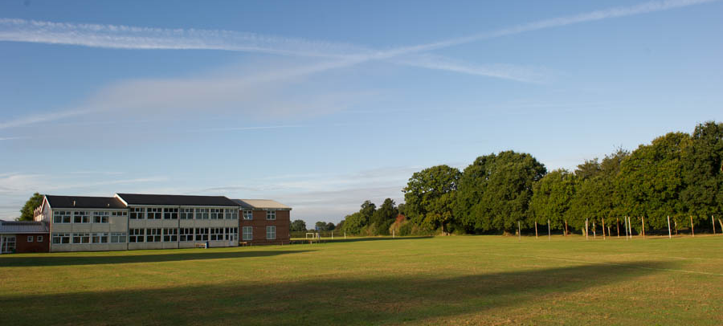

TEACHER OF SCIENCE: ASPIRING LEADER

Application Pack

Message from the Principal

St Benedict’s Catholic College is a highly respected and oversubscribed Roman Catholic 11-16 college serving Christian families throughout north-east Essex, we strive to promote the values of our Christian faith throughout our daily life.

Ofsted found us to be outstanding in its commitment to the social, moral and spiritual development of all its students. Our recent section 48 inspection found the college to have many other areas of outstanding practice. It’s a great place to be and I’m delighted that you are interested in applying to be part of our team

As our mission statement says, we are proud to be an inclusive community where spiritual, emotional and academic growth are nurtured. We believe in putting learning first.

Our facilities are excellent and we have a rich variety of extra-curricular opportunities that underpin our academic success. The college is set in pleasant, spacious grounds which include hard play areas, playing fields and tennis courts. We have a well-equipped sports hall and fitness suite. Our chapel is used regularly by students and staff for worship, prayer and quiet reflection.

Our students develop into happy confident and self-aware young adults. There are many opportunities for them to thrive and shine, through high quality teaching and numerous extra-curricular activities.

We are looking for a teacher of science who is aspiring to be Head of Science and seeks leadership development.

The successful candidate will be:
- committed to providing the very best learning opportunities for their students
- able to challenge all students to make exceptional progress
- a strong team player who forms excellent relationships with staff, parents and students
- willing to support the strong Catholic ethos of our college

We can offer you:
- a warm and welcoming college with excellent links to parish communities
- enthusiastic and well-behaved students who are eager to learn
- supportive, hardworking staff, governors and parents
- opportunities to further your professional development

If you would like any further information, or would like to arrange an informal visit, please contact Mr Peter Jeffery on 01206 549222.

The post is required 1st September 2019 and the closing date for applications is Monday 24TH January 2019 at 12.00 midday. Interviews will be held on Monday 4th February 2019.

Please apply by completing an application form which can be obtained from the College website www.stbenedicts.essex.sch.uk/vacancies or by emailing a.jones@stbenedicts.essex.sch.uk

The governing body is committed to safeguarding and promoting the welfare of all young people and expects all staff to share that commitment. The successful applicant will be required to complete an enhanced DBS check.

We look forward to hearing from you
Yours sincerely

Jo Santinelli
Principal

Flavour of the local area
The College is situated a short walk from Colchester Town Centre, Britain’s oldest recorded town.

Colchester is a thriving, modern town with great visitor attractions, including the family favourites Colchester Zoo and Colchester Castle, as well as fantastic places to eat, drink and shop

There is a growing arts scene in the town, with two highly acclaimed local theatres and the renowned Firstsite and Minories Galleries hosting significant art exhibitions and installations.

The town also benefits from a wide range of excellent schools and colleges as well as being the home of Essex University’s main campus.
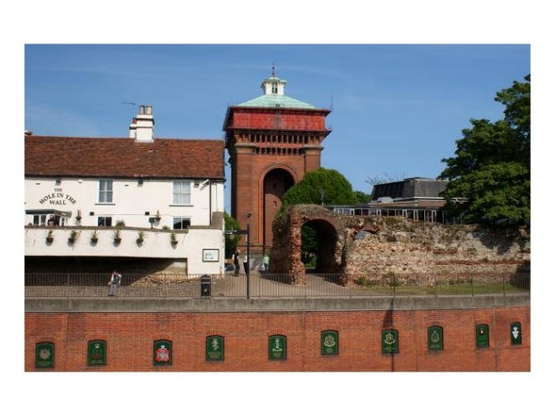
Colchester also benefits from superb transport links, including excellent road links, direct rail lines going into London (which is less than an hour away), and easy access to London Stansted and London Southend Airports which fly to a growing number of destinations throughout Europe.

SCIENCE TEACHER – Information about the department

St. Benedict’s Catholic College
St Benedict’s is a friendly and successful Catholic college where:

• the supportive ethos is remarked upon constantly
• standards are consistently high
• students and staff enjoy learning together
• positive attitudes and respect are the norm
• a culture of excellence and innovation is encouraged

St Benedict’s Catholic College Science Department

Staff

The science department comprises six full time staff. We now require a well-qualified science subject leader commencing September 2019.

Curriculum

In summer 2017 our year 11 achieved 73% 9- 4 in combined science. Our year 11 triple science students achieved 100% 9-4. Year 9-11 students are following the AQA combined trilogy course with selected students studying the three separate sciences.
At KS3 we band students in year 7, in year 8 they are taught in sets.
Ethos

In the department we operate in an atmosphere of sincere respect and friendship. We are all hard working and supportive of each other and would like our new colleague to share this ideal.

Accommodation

There are six laboratories, all of which have interactive projectors. The department is well equipped. The preparation room is spacious and the technical support offered by our two technicians is excellent.

I hope that you will be interested in the post. Should you have any questions or queries please contact me at the college.

Peter Jeffery

SCIENCE TEACHER – Job Description
St Benedict’s Catholic College is an inclusive college with Christ at the Centre. We nurture spiritual, emotional and academic growth. We develop our gifts and talents through prayer, work and respect.

Teacher salary range: MPS

Responsible to: Head of Department

Purpose:
- To contribute to the work of the department in maximising the achievement of all students
- To be accountable for the highest standards of achievement by all students taught, by monitoring, supporting and evaluating student achievement and setting targets for improvement

The Teachers’ Pay and conditions Document specifies the general professional duties of a teacher. Whilst every effort has been made to explain the main duties and responsibilities of the post, each individual task undertaken may not be identified.
You are expected to meet the DfE Teachers’ Standards

Particular duties
Under the direction of the Head of Department and the overall direction of the Principal.

General Duties:
- To act professionally, as a positive role model for students
- To undertake an appropriate programme of teaching in accordance with the duties of a standard scale teacher
- To assess, record and report on the development, progress and attainment of students
- To participate in arrangements for preparing students for external examinations, assessing students for the purpose of such examinations, recording and reporting such assessments; and participating in arrangements for students presentation for, and conducting, such examinations
- To assist in making appropriate arrangements for classes when staff are absent
- To exercise due caution and observe Health and Safety requirements in the conduct of their work

Main Duties:
Planning, Preparation and Assessment
- To plan and prepare courses and lessons, teaching, according to their educational needs, assigned students, including the setting and marking of work carried out by students in College and elsewhere
- To contribute to the whole College planning activities

Curriculum Provision
- To respond to curriculum development and initiatives at national, regional and local levels
- To share resources and to adhere to subject area policies, plans, targets and practices within the context of the College aims and policies
- To provide or contribute to written assessments, reports and references regarding the development, progress and attainment of all students taught

Staff Development
- To undertake appropriate CPD in line with college and departmental priorities
- To participate in the arrangements made for Performance Management Review
- To review, from time to time, methods of teaching and Schemes of Work.
- To participate in arrangements for further training and professional development as a teacher including undertaking training and professional development which aim to meet the needs identified in Performance Management objectives

Quality Assurance
- To participate in lesson observations in line with College policy and seek to implement modification and improvement where required.
- To contribute to the process of monitoring and evaluation of the curriculum in line with agreed College procedures, including evaluation against quality standards and performance criteria

Judge standards
- To agree, set and review targets for individual students and classes taught
- To discuss work, progress and attitudes with students

Evaluate teaching and learning
- Contribute to the evaluation of schemes of work to ensure that they focus on consistent and effective teaching and learning

Communication
- To provide effective communication/consultation as appropriate with the parents of students
- To communicate and co-operate with persons or bodies outside the College and participate in meetings arranged for the purposes of student progress

Personal Development and Wellbeing
- To promote and safeguard the welfare of children and young persons for whom specifically responsible or with whom there is contact
- To monitor and support the overall progress and well-being of individual students and class or groups of students.
- To ensure the Behaviour Management Policy is implemented, maintaining good order and discipline and safeguarding the health and safety of students, so that effective learning can take place, both when they are authorised to be on the College premises and when they are engaged in authorised College activities elsewhere.
- To make records on the personal and social needs of students.
- To positively use the College rewards system and sanctions and undertake appropriate actions
- To ensure that all students understand and are able to complete their work
- To ensure that all students complete their homework and coursework within set deadlines
- To contribute to PSHE, Citizenship and Enterprise Education according to College policy, providing guidance and advice to students on educational and social matters and on their further education and future careers, including information about sources of more expert advice
- To act as a Form Tutor and to carry out the duties associated with that role as outlined in the generic job description or to undertake alternative duties as agreed with the Headteacher.

Marketing and Liaison
- To take part in marketing and liaison activities such as Open Evenings and events with primary schools
- To contribute to the process of effective subject links with external agencies

Administration
- To participate in meetings at the College which relate to the curriculum for the College or the administration or organisation of the College
- To participate in meetings relating to pastoral and SEN arrangements for students as required
- To attend assemblies, registering attendance of students and supervising them
- To ensure that students are registered promptly and accurately using the electronic register wherever possible, whilst the group is silent
- To maintain appropriate records and to provide relevant, accurate and up-to-date information for the College management system
- To complete the relevant documentation to assist in the tracking of students
- To participate in administrative and organisational tasks related to such duties as are described above, including the direction or supervision of persons providing support for the teachers in the College

Notes:
- The above responsibilities are subject to the general duties and responsibilities contained in the statement of the Conditions of Employment
- The job description allocates duties and responsibilities but does not direct the amount of time to be spent carrying them out
- This job description is not necessarily a comprehensive definition of the post. It will be reviewed at least once a year and it may be subject to modification or amendment at any time after consultation with the post holder

Person Specification
Qualifications and experience | Essential | Desirable
Degree standard or equivalent
Good pass in English GCSE (or equivalent)
Good pass in Maths GCSE (or equivalent)
A relevant degree (or equivalent)
Qualified Teacher Status
Experience of teaching at KS3 & KS4
Experience of being a form tutor / pastoral care of students
Personal Qualities
Good organisational skills
Ability to work accurately with attention to detail
Stamina, energy, resilience and sense of humour
Calm and patient
Team player
Flexible
Skills and abilities
Ability to set high expectations which inspire, motivate and challenge students
Ability to promote good progress and outcomes by students
Ability to demonstrate good subject and curriculum knowledge
Ability to plan and teach well-structured lessons based upon accurate assessment
Ability to adapt teaching to respond to the strengths and needs of all students
Ability to manage behaviour effectively to ensure a productive and safe learning environment
Ability to fulfil wider professional responsibilities
Ability to communicate and work effectively with parents & colleagues
Ability to meet all deadlines & work well under pressure
Demonstrate a clear commitment to develop and learn in the role
Able to effectively evaluate own performance

St Benedict’s Catholic College
Norman Way
Colchester
Essex
CO3 3US
www.stbenedicts.essex.sch.uk

