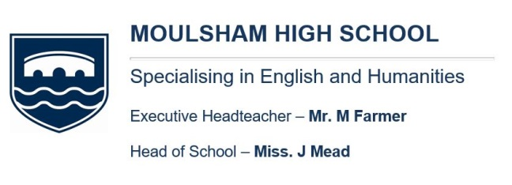

JOB DESCRIPTION

Title of Post: | Front of House Cleaning Assistant
Grade/Hours | 43 weeks per year (48.2 paid weeks)  Term Time including non-pupil days plus 4 weeks in holidays  Fixed Scale Point 9
Responsible to: | Cleaning Supervisor
Job Purpose: | To perform a variety of domestic/cleaning tasks at  Moulsham High School

DUTIES

Task | Key performance Indicators
To carry out and complete cleaning tasks in line with Moulsham High School standards, policies and working specification. | - Areas to be cleaned to the Daily Work Schedule and to the standard contained within the cleaning regime, under the direction of cleaning supervisor, or management team
To comply and follow the schools Health & Safety Rules for Safe Working and Chemical Handling. | - Carry out all cleaning tasks as you have been instructed  - Use the designated chemicals for each specific cleaning task  - Use the correct colour coded cleaning equipment  - Use the correct electrical equipment  - Use the supplied Personal Protective Equipment  - Safely use chemicals under the C.O.S.H.H regulations
To meet the schools standards of behaviour and present a professional approach.  To develop and maintain good working relationships with the School Staff, Cleaning Supervisor and fellow employees during their hours of work. | - Be ready for work at the start of each cleaning session.  - Behave in a polite manner to all School staff and pupils and other members of the cleaning team  - Follow company schools for appearance

Task | Key performance Indicators
To ensure correct usage of cleaning chemicals, materials and light equipment.  To prevent damage to fixtures, fittings, equipment and plant. | - Use the correct manufacturers recommended dilution ratios of cleaning chemicals.  - Ensure minimal wastage of materials.  - To ensure all chemicals, cleaning equipment and electrical equipment is stored and secured when not in use.
To isolate and report to the Cleaning  Supervisor all defective electrical equipment.  Report all accidents and near missies to your Cleaning Supervisor. | - Ensure all matters regarding security, Health & Safety and building maintenance are reported to your Cleaning Supervisor.

OTHER EXPECTATIONS

- To act on direction from the Cleaning Supervisor or management throughout the day, in a safe and purposeful manner.
- To perform all tasks in a safe and hygienic manner.
- To work with all members of the cleaning team and adopt a positive attitude and approach at all times.
- To be able to work on your own in some aspects of the job and to be able to perform well under pressure.
- To be able resolve any issues without direct supervision.
- To be able to prioritise and organise tasks and see them through to completion.
- To maintain professional standards with both staff and students at all times.

GENERAL

Such other duties relating to the use of the premises and site as may be necessary from time to time in accordance with established local practice or with the reasonable requirements of the school and Governing Body.
The duties may be varied by the Head of School and/or Governing Body to meet changed circumstances in a manner compatible with the post held.
The Trust and Local Governing Body is committed to safeguarding and promoting the welfare of children and young people and expects all staff and volunteers to share in this commitment

It is a requirement to:
- Participate in the performance and development review process, taking personal responsibility for identification of learning, development and training opportunities in discussion with line manager.
- Comply with individual responsibilities, in accordance with the role, for health & safety in the workplace
- Ensure that all School and Trust policies are adhered to.

CLEANING ASSISTANT – PERSON SPECIFICATION
General heading | Detail | Examples
Qualifications & Experience | Specific qualifications & experience | Experience of working in a cleaning team at a large site desirable  Relevant Qualifications
 | Knowledge of relevant policies and procedures | Knowledge of First Aid desirable  Understand general school policies and procedures
 | Literacy | Good reading and writing skills
 | Numeracy | Ability to count and undertake mathematical calculations
Communication | Written | Good written skills
 | Verbal | Ability to convey information clearly
 | Languages | Seek support to overcome communication barriers with children and adults
Working with children | Behaviour Management | Understand the school’s behaviour management policy
 | Health & Well being | Understand and support the importance of physical and emotional wellbeing
Working with others | Working with partners | Ability to make a proactive contribution to the work of the school team  Seek out, develop and maintain appropriate relationships with those involved with the site management function of the school
 | Relationships | Ability to establish rapport and respectful and trusting relationships with others
 | Team work | Ability to make an distinctive contribution to the work of a team
Responsibilities | Organisational skills | Excellent organisational skills  Ability to remain calm under pressure
 | Time Management | Ability to manage own time effectively  Demonstrate a flexible approach
 | Creativity | Demonstrate ability to resolve problems independently
General | Equalities | Awareness of and commitment to equality
 | Health & Safety | Understanding of Health & Safety regulations
 | C.O.S.H.H | Understanding of the C.O.S.H.H regulations
 | CPD | Demonstrate a clear commitment to develop and learn in the role  Ability to effectively evaluate own performance

NOTE:

This job description is not necessarily a comprehensive definition of the post and may be subject to modification or amendment at any time after consultation with the holder of the post.

