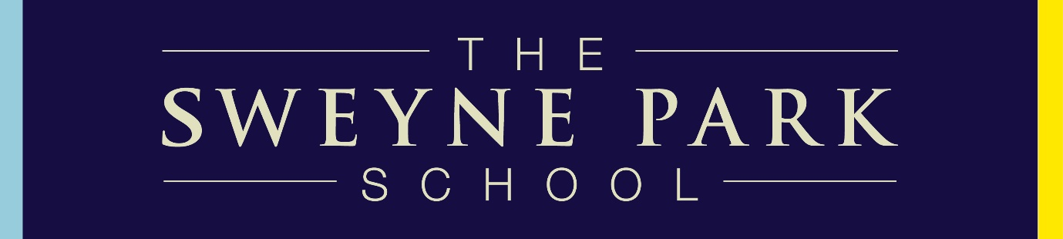

Information for Prospective Staff

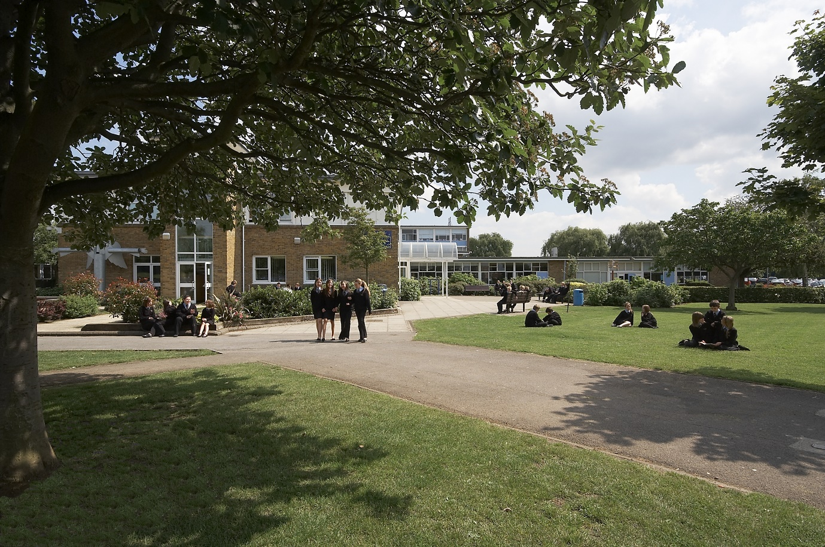

An Introduction to The Sweyne Park School

Welcome to The Sweyne Park School, we are a larger than average mixed, 11-18 comprehensive school. The School became an academy on 1st April 2013 and opened its Sixth Form in September 2014.

Our school is a safe and happy environment and central to our school is a belief in respect - respect for yourself, respect for others and respect for the environment. We believe that our focus on respect leads to high expectations and excellent discipline, and this in turn leads to the highest possible achievement for each individual pupil. In December 2018 we were the first Secondary School in the East of England to achieve the prestigious Rights Respecting Gold Award.

At Sweyne Park we are determined to provide first class teaching and learning for all our pupils. This aim is supported by our commitment to recruiting and retaining the very best staff, and our nationally recognised programme of staff training. We do our utmost to ensure our pupils achieve strong examination results and progress on to high quality destinations. We provide a broad and balanced academic curriculum with a wide range of cultural, artistic, sporting and social opportunities.

We are committed to very strong partnerships between home, school and community members. We believe that the whole community can contribute to motivating and supporting pupils’ progress.
In October 2017, the Sweyne Park School and Glebe Primary formed a Multi-Academy Trust, the Rayleigh Schools Trust (“The RST”).

Rayleigh Schools Trust Vision Statement

The RST oversees both schools, and believes every child is entitled to an outstanding education. A strong ethos of respect underpins everything we set out to achieve as a Trust. Our inclusive approach focuses on ensuring each individual child can flourish and succeed, and providing excellent teaching and learning opportunities for all. Building on Sweyne Park’s track record of school improvement, we believe the Rayleigh Schools Trust provides the right balance of challenge and support to both Sweyne Park and Glebe Primary, to secure ongoing improvements in standards and to build capacity. The reputation of both schools, as a truly inclusive environment in which to learn, continues to be at the heart of our vision and ambition. We use our strong involvement with the local community to build upon this. Our key values are:

- Aspiration for all
- An ethos of respect
- Ensuring high quality teaching
- Ensuring excellent progress and achievement for all
- An ethical approach
- A belief that “every child matters”
- A focus on community

Trustees ensure these key values are reflected through targets across the Trust, and progress is assessed at each meeting of the Board of Trustees.

The Sweyne Park School reserves the right to deploy the successful applicant across schools within the RST

The Sweyne Park School at a Glance

Summary of the School Development Plan 2020 – 2021

Priorities: Intended Outcomes 2020/2021

To secure the success of the school, ensuring it becomes the first choice for all families in the catchment area, through:

- Ensuring pupils enjoy school, and their behaviour is respectful at all times.

- Reconnecting pupils following the period of school closure. To achieve this by using the Re-Connection Curriculum:

Relationships
Engagement
Context (for Sweyne Park)
Opportunities
Nurture
Non-negotiables
Emotions
Caring
Togetherness

- Ensuring teachers received the necessary training to implement the Reconnecting Curriculum to effectively address gaps in pupils’ knowledge.

- Ensuring all teachers are clear about the intent of their curriculum area, and as effective in supporting pupils to make progress and gain knowledge and skills.

- Improving rates of progress for more-able pupils and those who are disadvantaged by focusing on barriers to learning.

- Providing a wealth of rich culture experiences to develop pupils’ character and encourage them to have a deep appreciation of the Arts

A copy of the full School Development Plan is available, on request, from Kerry Wilby
in the Main School Office.

Curriculum Vision Statement

The purpose of our curriculum and of our work as a Thinking School is to inspire pupils, to secure strong academic outcomes and engender in them an enduring sense of curiosity. By exploring the broad and rich variety of subjects we offer, pupils can find their unique strengths, value their own ability to learn, find their voice and use it with confidence and eloquence. They can grow into truly independent learners who are inspired and driven to learn.

Our curriculum is designed to give each pupil a broad and secure body of knowledge about the world around them, and the perspectives and lives of others living both now and in the past. In addition to this, they learn about the key scientific, literary, mathematical, artistic and technological achievements of the human race to date. Through their learning, pupils will develop their thinking skills and practical abilities. They will learn to analyse, evaluate, make judgements and justify their reasoning. Reports now include a curriculum overview statement for every subject. This helps parents and carers to understand the curriculum intent. Pupils are empowered to make choices about the subjects they will study in Key Stage 4. Decisions about syllabus selections are made with a view to facilitate the richest learning experience rather than what is expedient for league tables. Our approach is ethical and supports Post 16 choices and progression, and to this end we opened a Sixth Form in 2014. We are committed to ensuring all pupils have high aspirations, make informed decisions relating to the world of work, and have the skills and habits of mind, which will secure their success.

Over several years now, departments have built comprehensive curriculum maps which place great emphasis on developing skills and confidence. Teachers are constantly adapting and improving these schemes, pre-empting and addressing misconceptions and developing in their pupils a love of learning.

Cross-curricular themes are valued, but we believe in the rigour and purity of discrete subject disciplines to explore the human condition. In 2008, departments formed their own vision statements summarising the intent and purpose of their curriculum. These have evolved over time and are shared with pupils. They provide an anchor which underpin lessons, bringing a cohesive sense of meaning and purpose to every lesson. All teachers interviewed since 2006 have been asked about the philosophical essence of their subject, and we expect teachers to be able to articulate this.

Teachers actively develop pupils’ schema and ensure that new knowledge is both retained and accessible from the long term memory. We look to inspire and support all pupils, giving them a thirst for learning, satisfied through hard work. Our school is a highly inclusive one, where barriers to learning are actively sought and overcome.

We offer a broad curriculum and a diverse extra-curricular offer. Our Key Stage 3 curriculum has always been taught over three full years. This gives a breadth of knowledge and skills which pupils can draw from as they specialise and make choices. We value the Arts and pupils are encouraged and supported to explore and develop their creativity, and are given the opportunity to discover their talents. The Arts are integral to the ethos of the school, challenge and sustain our culture, valuing every human being as an individual, as well as recognising and celebrating the great mystery of life.

Crucially, our curriculum also supports spiritual development, and looks to build in our pupils a moral strength that enables them to understand and express their identity and actively contribute to society and life in modern Britain. The values of respect and rights are at the heart of our school and are recognised through our work as a UNICEF Rights Respecting Gold School.

A Rights Respecting School, A Thinking School

The Sweyne Park School has always had a strong ethos of respect, centred on three key principles: respect for yourself, respect for others and respect for the environment. As part of this, the school undertook a journey to become a UNICEF Rights Respecting School, putting the United Nations Convention on the Rights of the Child (UNCRC) at the heart of what we do. Children and adults at Sweyne Park are taught about the UNCRC and, crucially, of the importance of respecting everyone’s rights, including your own. In November 2018 UNICEF accredited Sweyne Park as a Gold Rights Respecting School, becoming the only secondary school in the East of England region to achieve this status. Children’s rights and the importance of respect remain central to our values as a school.
At Sweyne Park pupils are seen as active and vital participants in their education. Their opinions are sought and valued. An active school council frequently discusses matters relating to teaching and learning and teachers. The outcomes of these discussions, along with the views of parents and staff, are a valuable sources of information used in the school’s evaluation and development processes.

In recent years, the school has done a great deal of work to ensure pupils develop as effective and confident thinkers. This has involved all staff. Sweyne Park School teachers read and share current research relating to the brain and how people learn. Teachers are encouraged to engage in further study and a high proportion of teachers have or are working towards gaining a Masters’ degree.

Weekly professional development workshops are an established part of the school’s development programme and increasingly middle leaders lead this training under the direction of the Deputy Headteacher. Developments are shared with the whole body of staff through the weekly school bulletin and via the staff training VLE site.

The Application Process

Applicants are requested to read the information carefully, especially the job description and person specification. Please ensure that your application satisfies all the criteria in the person specification and you display evidence of this. Please specify the role that you are applying for, and ensure that you complete an Essex Application Form (available online or, by request from the school) and return it, together with a covering letter, addressed to the “Mrs Katharine Dines – CEO of the Rayleigh Schools Trust”.

Applicants must ensure that they provide two references, and please note that the first reference should normally be your present, or most recent, Headteacher.

Once you have completed your application please print, sign and return either by post to:

Mrs Katharine Dines
CEO Rayleigh Schools Trust
c/o The Sweyne Park School
Sir Walter Raleigh Drive
Rayleigh
Essex, SS6 9BZ

Or by email to: admin@sweynepark.com

If you have any queries, please contact Kerry Wilby, Headteacher’s PA, on 01268 784721 or at kwilby@sweynepark.com

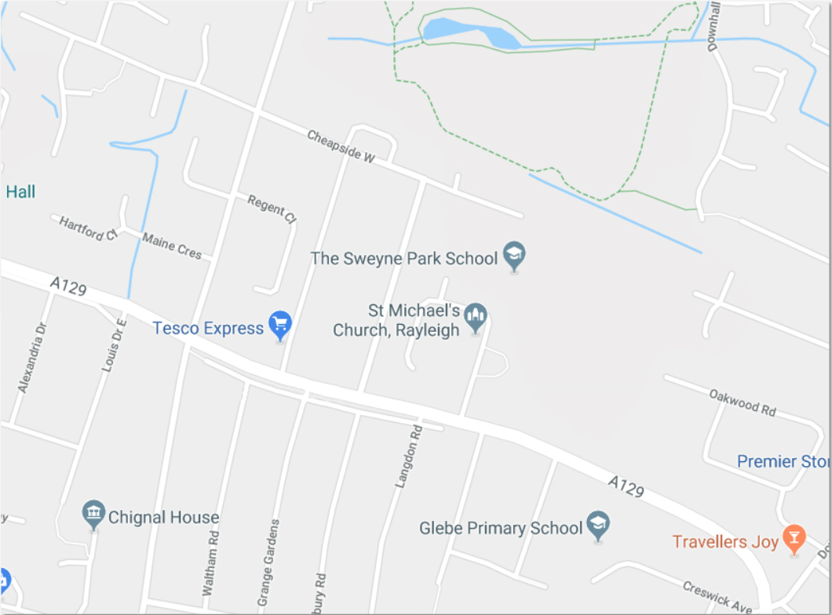

Contact Us

Tel: 01268 784721
Email: admin@sweynepark.com
Website: www.sweynepark.com

