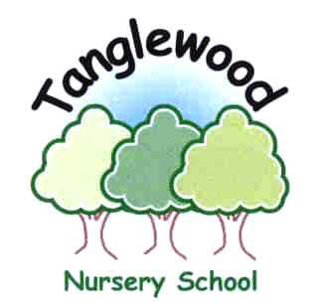 Person Specification
Classroom Teacher

Formal Qualifications  Essential  Desirable | - Qualified Teacher Status  - Evidence of further professional development
Experience  Essential  Desirable | - Teaching experience within EYFS  - A commitment to quality early years education  - Evidence of successful practice working with other staff members  - Experience of working successfully using ICT
Professional skills and Knowledge  Essential  Desirable | - A clear knowledge and understanding of the Early Years Foundation Stage curriculum  - A clear knowledge and understanding of how children learn through play  - A knowledge of assessment in the Early Years  - A knowledge of child development and the ability to respect, recognise and respond to the individuality of pupils  - Demonstrate the use of a variety of teaching styles to motivate and engage learners  - High expectations for pupils and staff  - The commitment to the inclusion of children with special needs in the mainstream school environment  - A commitment to involving parents and carers in the children’s learning  - Awareness of national trends and developments
Personal Skills | - The ability to communicate effectively both verbally and in writing  - Genuine care and respect for young children  - Eagerness to support the whole school ethos  - An ability to motivate and support other staff in their work  - Able to manage adults in the classroom  - Well developed interpersonal skills and the ability to develop and maintain good relationships with staff, parents/carers, pupils and students  - Personal and professional integrity  - Good organisational skills

The Governing Body is committed to safeguarding and promoting the welfare of children and young people and expects all staff and volunteers to share this commitment.

This post will only be offered subject to satisfactory references, medical and CRB checks.

